Exp:11
#include <stdio.h>
#include <stdlib.h>
#include <string.h>

int cnt = 0;

struct symtab
{
char label[20];
int addr;
} sy[50];

void insert();
int search(char *);
void display();
void modify();

int main()
{
int ch, val;
char lab[20];

do
{
printf("\n1. Insert");
printf("\n2. Display");
printf("\n3. Search");
printf("\n4. Modify");
printf("\n5. Exit");
printf("\nEnter your choice: ");
scanf("%d", &ch);

switch (ch)
{
case 1:
insert();
break;

case 2:
display();
break;

case 3:
printf("Enter the label: ");
scanf("%s", lab);

val = search(lab);

if (val == 1)
printf("Label is found\n");
else
printf("Label is not found\n");

break;

case 4:
modify();
break;

case 5:
exit(0);

default:
printf("Invalid choice\n");
}

} while (ch < 5);

return 0;
}

void insert()
{
int val;
char lab[20];

printf("Enter the label: ");
scanf("%s", lab);

val = search(lab);

if (val == 1)
{
printf("Duplicate symbol\n");
}
else
{
strcpy(sy[cnt].label, lab);

printf("Enter the address: ");
scanf("%d", &sy[cnt].addr);

cnt++;

printf("Symbol inserted successfully\n");
}
}

int search(char *s)
{
int i;

for (i = 0; i < cnt; i++)
{
if (strcmp(sy[i].label, s) == 0)
{
return 1;
}
}

return 0;
}

void modify()
{
int val, ad, i;
char lab[20];

printf("Enter the label: ");
scanf("%s", lab);

val = search(lab);

if (val == 0)
{
printf("No such symbol\n");
}
else
{
printf("Label is found\n");
printf("Enter the new address: ");
scanf("%d", &ad);

for (i = 0; i < cnt; i++)
{
if (strcmp(sy[i].label, lab) == 0)
{
sy[i].addr = ad;
printf("Address modified successfully\n");
break;
}
}
}
}

void display()
{
int i;

if (cnt == 0)
{
printf("Symbol table is empty\n");
return;
}

printf("\nSymbol Table\n");
printf("Label\tAddress\n");

for (i = 0; i < cnt; i++)
{
printf("%s\t%d\n", sy[i].label, sy[i].addr);
}
}

Output:
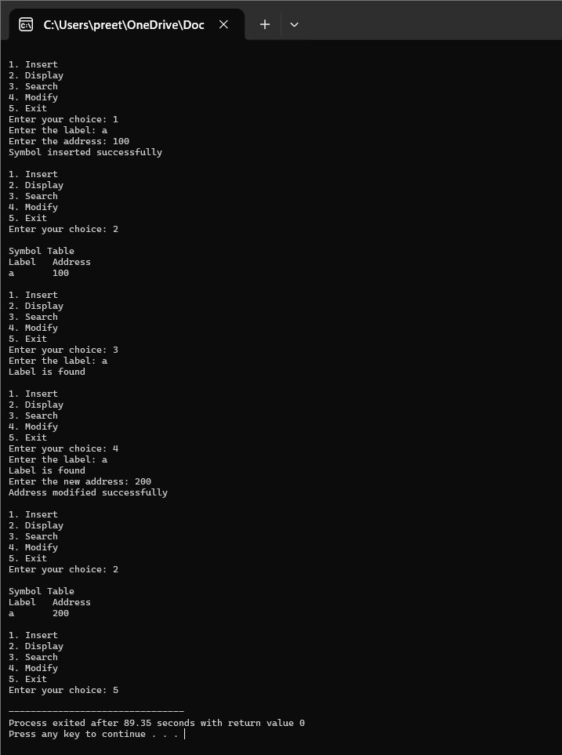

Exp:12
#include <stdio.h>
#include <string.h>

char input[100];
int i = 0;

int E();
int EP();
int T();
int TP();
int F();

int main()
{
printf("\nRecursive Descent Parsing\n");
printf("\nGrammar:");
printf("\nE -> TE'");
printf("\nE' -> +TE' / @");
printf("\nT -> FT'");
printf("\nT' -> *FT' / @");
printf("\nF -> (E) / ID");

printf("\n\nEnter the string to be checked: ");
scanf("%s", input);

i = 0;

if (E() && input[i] == '\0')
printf("\nString is accepted");
else
printf("\nString is not accepted");

return 0;
}

int E()
{
if (T())
return EP();

return 0;
}

int EP()
{
if (input[i] == '+')
{
i++;

if (T())
return EP();

return 0;
}

return 1;
}

int T()
{
if (F())
return TP();

return 0;
}

int TP()
{
if (input[i] == '*')
{
i++;

if (F())
return TP();

return 0;
}

return 1;
}

int F()
{
if (input[i] == '(')
{
i++;

if (E())
{
if (input[i] == ')')
{
i++;
return 1;
}
}

return 0;
}

if ((input[i] >= 'a' && input[i] <= 'z') ||
(input[i] >= 'A' && input[i] <= 'Z'))
{
i++;
return 1;
}

return 0;
}
Output:
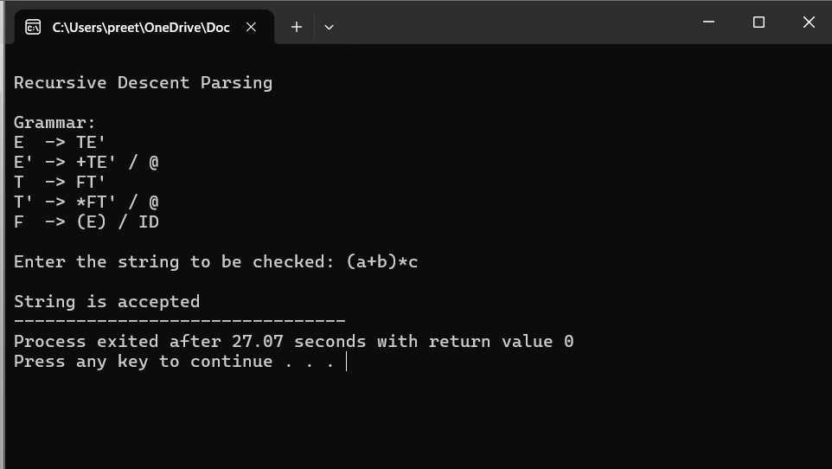
Exp:13
#include <stdio.h>
#include <string.h>

int main()
{
char string[50];
int i, flag = 0, valid = 1;

printf("The grammar is: S -> aS | Sb | ab\n");
printf("Enter the string to be checked: ");
scanf("%s", string);

/* String must start with 'a' and end with 'b' */
if (string[0] != 'a')
{
valid = 0;
}
else
{
for (i = 1; string[i] != '\0'; i++)
{
if (string[i] == 'b')
flag = 1;
else if (string[i] == 'a' && flag == 1)
{
valid = 0;
break;
}
else if (string[i] != 'a' && string[i] != 'b')
{
valid = 0;
break;
}
}

/* At least one b must be present */
if (flag == 0)
valid = 0;
}

if (valid)
printf("String accepted");
else
printf("String not accepted");
return 0;
}
Output:
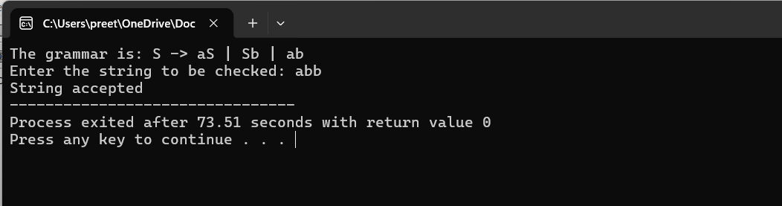
Exp:14
#include <stdio.h>
#include <string.h>
#include <stdlib.h>

char input[50], stack[50];
int top = -1, i = 0;

void shift();
int reduce();

int main()
{
printf("\n\tSHIFT REDUCE PARSER\n");

printf("\nGRAMMAR:");
printf("\nE -> E+E");
printf("\nE -> E/E");
printf("\nE -> E*E");
printf("\nE -> a");
printf("\nE -> b");

printf("\n\nEnter the input symbol: ");
scanf("%s", input);

printf("\nStack\t\tInput\t\tAction\n");

while (input[i] != '\0')
{
shift();

if (reduce())
continue;
}

while (reduce());

if (top == 0 && stack[0] == 'E')
printf("$E\t\t$\t\tACCEPT\n");
else
printf("$%s\t\t$\t\tREJECT\n", stack);

return 0;
}

void shift()
{
stack[++top] = input[i];

printf("$%.*s\t\t%s\t\tSHIFT %c\n",
top + 1, stack, input + i + 1, input[i]);

i++;
}

int reduce()
{
/* E -> a */
if (top >= 0 && (stack[top] == 'a' || stack[top] == 'b'))
{
char ch = stack[top];
stack[top] = 'E';

printf("$%.*s\t\t%s\t\tREDUCE E->%c\n",
top + 1, stack, input + i, ch);

return 1;
}

/* E -> E+E */
if (top >= 2 &&
stack[top - 2] == 'E' &&
stack[top - 1] == '+' &&
stack[top] == 'E')
{
top -= 2;
stack[top] = 'E';

printf("$%.*s\t\t%s\t\tREDUCE E->E+E\n",
top + 1, stack, input + i);

return 1;
}

/* E -> E*E */
if (top >= 2 &&
stack[top - 2] == 'E' &&
stack[top - 1] == '*' &&
stack[top] == 'E')
{
top -= 2;
stack[top] = 'E';

printf("$%.*s\t\t%s\t\tREDUCE E->E*E\n",
top + 1, stack, input + i);

return 1;
}

/* E -> E/E */
if (top >= 2 &&
stack[top - 2] == 'E' &&
stack[top - 1] == '/' &&
stack[top] == 'E')
{
top -= 2;
stack[top] = 'E';

printf("$%.*s\t\t%s\t\tREDUCE E->E/E\n",
top + 1, stack, input + i);

return 1;
}

return 0;
}
Output:
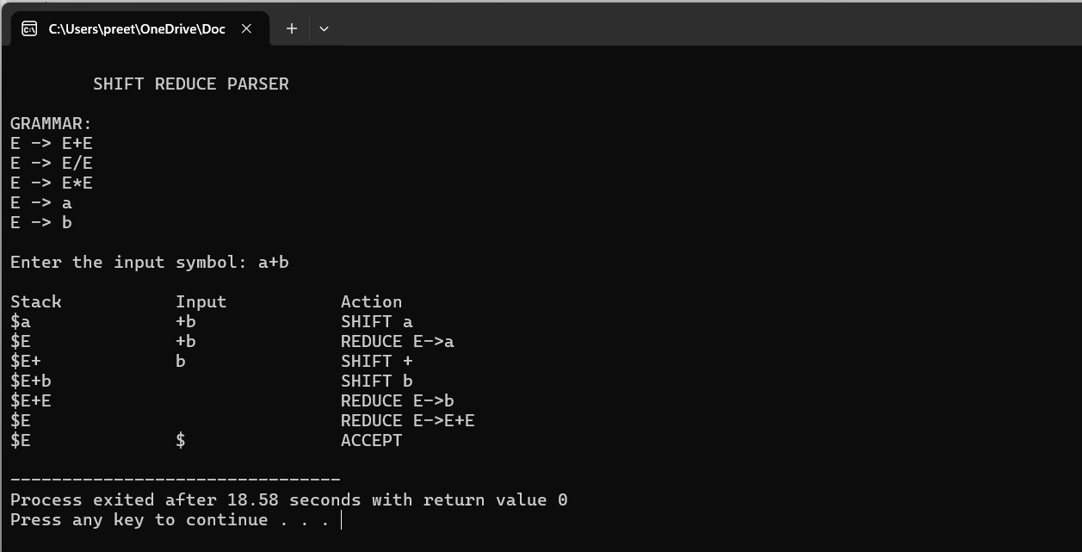
Exp:15
#include <stdio.h>
#include <stdlib.h>
#include <string.h>

char input[50], stack[50];
int top = 0, ip = 0;

char handles[][6] = {
"(E)",
"E*E",
"E/E",
"E+E",
"E-E",
"E^E",
"i"
};

char lastHandle[10];

/* Return precedence */
int precedence(char c)
{
if (c == '+' || c == '-')
return 1;

if (c == '*' || c == '/')
return 2;

if (c == '^')
return 3;

if (c == 'i' || c == ')')
return 4;

if (c == '(')
return 0;

return -1;
}

/* Display stack and input */
void display(char action[])
{
int j;

printf("\n");

for (j = 0; j <= top; j++)
printf("%c", stack[j]);

printf("\t\t");

for (j = ip; input[j] != '\0'; j++)
printf("%c", input[j]);

printf("\t\t%s", action);
}

/* Find terminal at top of stack */
char topTerminal()
{
int j;

for (j = top; j >= 0; j--)
{
if (stack[j] != 'E')
return stack[j];
}

return '$';
}

/* Reduce handle */
int reduce()
{
int i, len, j, found;

for (i = 0; i < 7; i++)
{
len = strlen(handles[i]);

if (top + 1 >= len)
{
found = 1;

for (j = 0; j < len; j++)
{
if (stack[top - j] != handles[i][len - 1 - j])
{
found = 0;
break;
}
}

if (found)
{
top = top - len + 1;
stack[top] = 'E';
stack[top + 1] = '\0';

strcpy(lastHandle, handles[i]);

return 1;
}
}
}

return 0;
}

int main()
{
char action[30];
char t;
int p1, p2;

printf("\nEnter the string\n");
scanf("%s", input);

strcat(input, "$");

stack[0] = '$';
stack[1] = '\0';

printf("\nSTACK\t\tINPUT\t\tACTION");

while (1)
{
/* If input is finished, reduce remaining handles */
if (input[ip] == '$')
{
while (reduce())
{
sprintf(action, "Reduced: E->%s", lastHandle);
display(action);
}

break;
}

/* Shift */
stack[++top] = input[ip];
stack[top + 1] = '\0';

ip++;

display("Shift");

/* Reduce when appropriate */
while (1)
{
if (input[ip] == '$')
{
if (reduce())
{
sprintf(action, "Reduced: E->%s", lastHandle);
display(action);
continue;
}
break;
}

t = topTerminal();

p1 = precedence(t);
p2 = precedence(input[ip]);

/*
* Reduce if stack operator has higher precedence.
* For +,-,*,/ left associativity is used.
* ^ is right associative.
*/
if (t == '^' && input[ip] == '^')
break;

if (p1 >= p2 && t != '(')
{
if (reduce())
{
sprintf(action, "Reduced: E->%s", lastHandle);
display(action);
}
else
break;
}
else
break;
}
}

/* Final reductions */
while (reduce())
{
sprintf(action, "Reduced: E->%s", lastHandle);
display(action);
}

if (strcmp(stack, "$E") == 0 && input[ip] == '$')
printf("\nAccepted;");
else
printf("\nNot Accepted;");

return 0;
}
Output:
